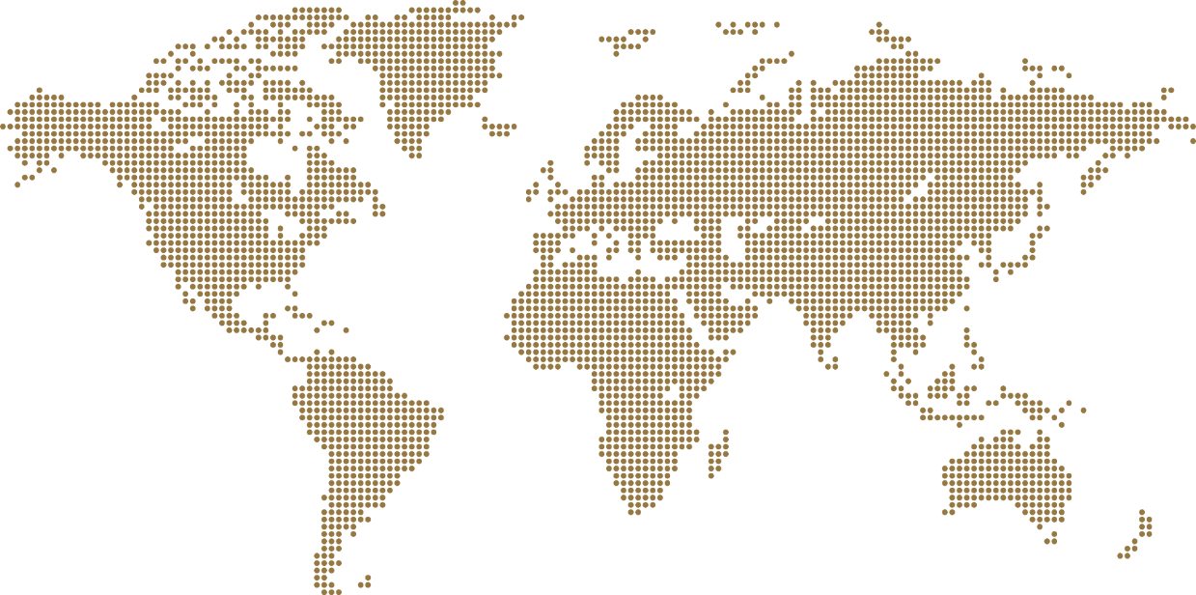
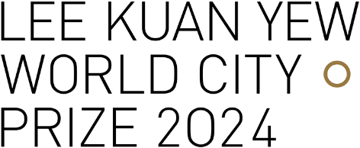
STAGE B SUBMISSION REPORT

- Your city must be nominated for Stage A before you proceed with Stage B.
- More info on Stage A: www.leekuanyewworldcityprize.gov.sg/stage-a
- More info on Stage B: www.leekuanyewworldcityprize.gov.sg/stage-b
- There are three (3) sections to this report:
- City portfolio: Brief information on the city
- Master Plan or Strategy: Brief information on the overall master plan or strategy for the city
- Three (3) demonstration projects: Information on three (3) demonstration projects to illustrate the success of the overall Master Plan or Strategy
- Please complete all parts of this report in English. More info on evaluation criteria: www.leekuanyewworldcityprize.gov.sg/evaluations/#judging-criteria

Contents Page

1 | Section A | City Portfolio |  | Click here
2 | Section B | Overall Master Plan or Strategy |  | Click here
3 | Section C | Demonstration Projects | Demonstration Project 1 | Click here
 |  | Demonstration Project 2 | Click here
 |  | Demonstration Project 3 | Click here
4 | Annex A | Demonstration Project Types |  | Click here

Section A | City Portfolio

Background on city

1 | City
2 | Province/state/region
3 | Country
4 | Mayor or Governor
5 | Term in office

- Please insert a map of the city, ideally outlining the area under the Mayor’s or Governor’s jurisdiction.
Image

Leadership and governance

- What is the governance structure of the city (e.g., mayor-council, commission, city manager)? You may wish to include an organisation chart to illustrate.
Answer

- What roles did the city leaders (past and present) play to transform the city?
Answer

- Who are the key organisations and stakeholders involved in the city’s transformation?
Answer

Section B | Overall Master Plan or Strategy

- Background information

1 | Name of Master Plan or Strategy
2 | When was the Master Plan or Strategy implemented?
3 | Effective period
4 | Vision of Master Plan or Strategy
5 | Link to the Master Plan or Strategy document online (if available)

- Key strategies

- Describe up to three key strategies of the Master Plan or Strategy.
Answer

- What are some new ideas that were implemented under the Master Plan or Strategy?
Answer

- Integration of plans

- Is the Master Plan or Strategy integrated with the region or neighbouring cities? If so, how?
Answer

- Impacts

- How has the Master Plan or Strategy impacted the city? (e.g., in the areas of economy, housing, sustainable transportation, environment, quality of life, etc.)
Answer

- Sustainability of the transformation

- How does the city ensure that the plans will continue despite leadership changes?
Answer

- Changing demographics

- How does your city address ageing population?
Answer

- Briefly describe up to three key strategies that your city implemented or intends to implement to improve quality of life, especially for vulnerable groups (e.g., migrants, low-income residents, minorities, etc.).
Answer

- Climate change

- Briefly describe up to three key strategies that your city implemented or intends to implement to mitigate the effects of climate change.
Answer

Section C | Demonstration Project 1

- Background information

1 | Project name
2 | Type of project  (Refer to Annex A)
3 | Size or scale  (if applicable)
4 | Location
5 | Year of completion
6 | Link to project info online (if available)

- Objectives

- What are the objectives of the project? (i.e., what issues did the project seek to address?)
Answer

- Key strategies

- What are the key strategies or actions taken? (i.e., how did the city implement the project?)
Answer

- What are some new ideas implemented?
Answer

- Impacts

- What are the impacts of the project? (e.g., to the local community and/or the urban environment)
Answer

Demonstration Project 2

- Background information

1 | Project name
2 | Type of project  (Refer to Annex A)
3 | Size or scale  (if applicable)
4 | Location
5 | Year of completion
6 | Link to project info online (if available)

- Objectives

- What are the objectives of the project? (i.e., what issues did the project seek to address?)
Answer

- Key strategies

- What are the key strategies or actions taken? (i.e., how did the city implement the project?)
Answer

- What are some new ideas implemented?
Answer

- Impacts

- What are the impacts of the project, such as to the local community and/or the urban environment?
Answer

Demonstration project 3

- Background information

1 | Project name
2 | Type of project  (Refer to Annex A)
3 | Size or scale  (if applicable)
4 | Location
5 | Year of completion
6 | Link to project info online (if available)

- Objectives

- What are the objectives of the project? (i.e., what issues did the project seek to address?)
Answer

- Key strategies

- What are the key strategies or actions taken? (i.e., how did the city implement the project?)
Answer

- What are some new ideas implemented?
Answer

- Impacts

- What are the impacts of the project, such as to the local community and/or the urban environment?
Answer

Annex A | Demonstration Project Types (Non-exhaustive)

 | Category | Types
1 | Governance | Governance re-structuring | Public services/e-governance
 |  | Participatory planning processes | Public-private partnerships
2 | Urban regeneration | Brownfield redevelopment | Conservation of heritage
 |  | Public spaces development
3 | Adapting to climate change | Energy transition/low carbon | Flood protection
 |  | Storm-water management | Disaster mitigation
4 | Environmental projects | Urban greenery/ecology | City beautification
 |  | Urban agriculture | Water management
 |  | Waste management
5 | Economic development initiatives | Industry development | Regional or international events
 |  | Tourism development
6 | Sustainable transport | Transport infrastructure | Shared mobility
 |  | Electric vehicles | Traffic/transport management
 |  | Urban logistics
7 | Social equity | Affordable housing | Social integration initiatives
 |  | Universal design | Shared spaces
8 | Smart city initiatives | Smart technology | Big data
9 | Others | COVID-19 measures | Others

Directory

Prize Secretary Ms Yap Lay Bee
Mailing address c/o Urban Redevelopment Authority
45 Maxwell Road
The URA Centre, Tower, #13-01
Singapore 069118
Email leekuanyew_worldcityprize@ura.gov.sg
Website www.leekuanyewworldcityprize.gov.sg
YouTube @leekuanyewworldcityprize

All Rights Reserved. Copyright 2023 © Urban Redevelopment Authority Singapore. No parts of this document may be reproduced or circulated to unrelated third parties without prior permission from the Lee Kuan Yew World City Prize Secretariat

