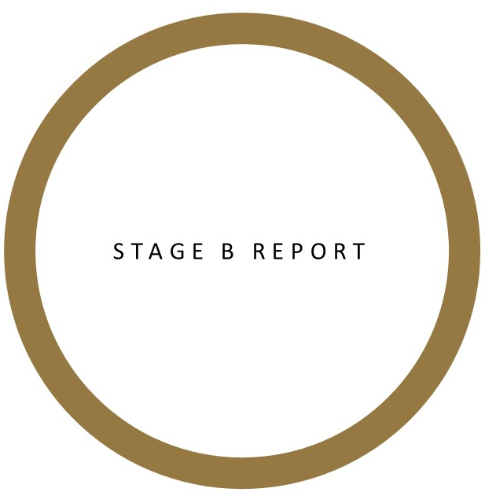

City

Focus for 2024 Prize: Emerging issues such as adapting to climate change,
addressing social equity, building urban resilience to counter shock events, etc.
- As cities around recover from the COVID-19 pandemic, how can they creatively adapt/transform short-term measures that addressed immediate demands to meet longer-term goals and objectives?
- How can cities increase their resiliency to bolster against future shocks?
- What can cities do to bridge the gaps of social equity?
- What immediate measures and long-term plans do cities need to take to adapt to and limit the adverse effects of climate change?

Please read the following before proceeding:

- Your city must be nominated for Stage A before you proceed with this report. For more information on Stage A Nomination, visit: go.gov.sg/stagea

- There are four (4) parts to Stage B Submission. This report refers to Part II. For more information on Stage B Submission, visit: go.gov.sg/stageb

Part | Item | Remarks
I | Key statistics | Key statistics comparing the city today and 10-20 years.
II | Detailed report | Use this template
III | Reference letters | At least 2 but not more than 5 reference letters (approx. 600 words each) written and signed by independent third parties who can provide testimony to the success of the city’s urban transformation.
IV | Supporting documents | Optional documents to support the submission.

- There are four (4) sections to this report:

Section | Item | Remarks
A | City portfolio | Information on the city
B | Master Plan or Strategy | Information on the overall master plan or strategy for the city
C | Three (3) demonstration projects | Information on three (3) demonstration projects to illustrate the success of the overall Master Plan or Strategy in Section B
D | Photo gallery | Photos to illustrate Sections A, B and C

- Please complete all parts of this report in English. You may require some time and additional resources to complete this report. An incomplete report may not be considered for evaluation.

- The Stage B Submissions for the 2024 Prize are reviewed independently of past submissions, i.e., information submitted for previous cycles will not be considered.

- For more information on the evaluation criteria, visit: go.gov.sg/criteria
SECTION A | CITY PORTFOLIO

City and leadership
1 | City
2 | Province/state/region  (if applicable)
3 | Country
4 | Mayor (or equivalent)
5 | Mayor’s term in office | Click here to enter a date. | to | Click here to enter a date.
Map of the city
6 | Please provide a map (with scale) indicating the boundary of:  - The city area (area under Mayor’s jurisdiction)  - The greater area, e.g., province/state/region (if available)  - Urban and rural areas within city (if available)  - City centre or Central Business District (if available)
 | 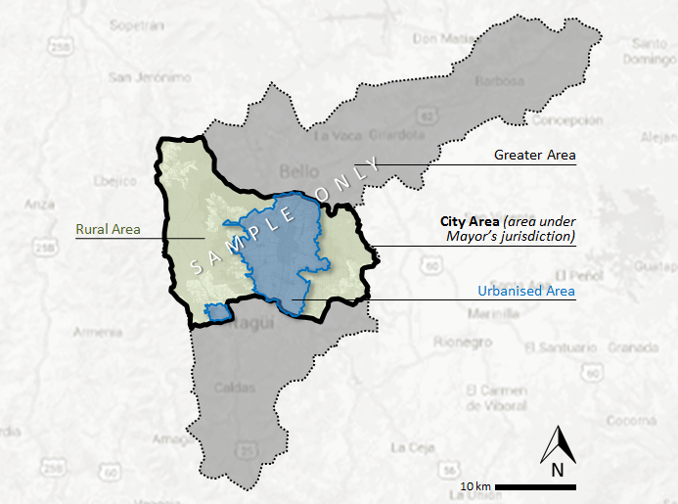

Significant projects/major events
7 | List the significant projects (completed or ongoing) and/or significant regional/international events that your city has undertaken in the past 5-10 years, e.g., major sporting events, large-scale urban infrastructure, etc. List no more than 5 items.
 | i.
 | ii.
 | iii.
 | iv.
 | v.
City accolades/rankings
8 | List the significant city accolades/liveability rankings that your city has attained in the past 5-10 years. List no more than 5 items.
 | i.
 | ii.
 | iii.
 | iv.
 | v.
Brief description of the city
9 | Briefly describe your city, e.g., history, geography, city demographics, economy, culture, and/or any other interesting facts, etc.
SECTION B | MASTER PLAN OR STRATEGY OF THE CITY

Please include relevant diagrams where applicable.

Overall Master Plan or Strategy of the city
1 | Name of Master Plan or Strategy
2 | When was the Master Plan or Strategy implemented? |  | Click here to enter a date.
3 | Period of Master Plan or Strategy |  | Click here to enter a date. | to | Click here to enter a date.
4 | Next review date |  | Click here to enter a date.
5 | Vision statement
6 | What issues did the Master Plan or Strategy sought to address?
Integration of plans
7 | How is the Master Plan or Strategy integrated with regional plans or with neighbouring cities (if applicable)?
8 | How is the Master Plan or Strategy funded (e.g., provincial/national budget, strategic land sales, public-private partnerships, etc.)?
Leadership and Governance
9 |  | What is the governance structure of the city (e.g., mayor-council, commission, city manager)? You may wish to include an organisation chart to illustrate.
10 |  | How did the city’s leaders (past and present) bring about the overall transformation of the city?
11 |  | Who are the key organisations and stakeholders involved in the city’s transformation?

Creativity and innovation
12 | What are the key strategies and actions of the Master Plan or Strategy?
13 | What are some new ideas that were implemented or developed?

Impact of urban initiatives implemented
14 | How has the Master Plan or Strategy impacted the city in the following areas? (Please provide figures/data wherever possible)
 | Economy
 | Housing
 | Transportation
 | Environment/ ecology
 | Social stability/ quality of life

Sustainability of the transformation
15 | How does the city ensure the continuity of the plans, in the event of changes in the leadership? Is the Master Plan or Strategy a continuation of earlier plans?
Special focus I: social equity
16 | What are your social integration strategies to address changing demographics and vulnerable groups, (e.g., ageing population, new residents/migrants/refugees, unemployed youths, the poor, minorities, etc.)?
Special focus II: climate change & urban resilience
17 | What are your key plans (in brief) to address and mitigate the effects of climate change (e.g., sustainable transportation, energy efficiency, renewables, resilience to shock events, resources sufficiency, etc.)?

SECTION C | DEMONSTRATION PROJECTS

- Please provide information on three (3) key demonstration projects of a suitable scale, implementation effort, and impact to illustrate the success of the Master Plan or Strategy in SECTION B.
- Please refer to ANNEX A for a non-exhaustive list of project types.
- Please include relevant diagrams where applicable.

Demonstration Project 1
Background
1 | Project name
2 | Type  (refer to Annex A) |  | Choose an item.  Others:
4 | Size  (if applicable)
5 | Location
6 | Lead agency/ organisation
7 | Other stakeholders involved
8 | Status |  | Project completion status (Click wherever applicable) | ☐ | Completed
 |  |  |  |  | Year of completion:
 |  |  |  | ☐ | Ongoing
 |  |  |  |  | Expected year of completion:
 |  |  | No. of years to implement
 |  |  | Current phase/status
9 | Accolades, if any (List no more than 5 items)
 | i.
 | ii.
 | iii.
 | iv.
 | v.

Key issues before implementation
9 | What were the key issues faced before the implementation of the project?
Objectives
10 | What are the key objectives for the project?
Key strategies
11 | What are the key strategies and actions taken?
Creativity and innovation
12 | What are the new ideas implemented?

Impacts of project
13 | How has the project effected positive change on the urban environment and local community?
Replicability
14 | Is the project adapted from existing examples? How can the project benefit other areas of the city or other cities?

Demonstration Project 2
Background
1 | Project name
2 | Type  (refer to Annex A) |  | Choose an item.  Others:
4 | Size  (if applicable)
5 | Location
6 | Lead agency/ organisation
7 | Other stakeholders involved
8 | Status |  | Project completion status (Click wherever applicable) | ☐ | Completed
 |  |  |  |  | Year of completion:
 |  |  |  | ☐ | Ongoing
 |  |  |  |  | Expected year of completion:
 |  |  | No. of years to implement
 |  |  | Current phase/status
9 | Accolades, if any (List no more than 5 items)
 | i.
 | ii.
 | iii.
 | iv.
 | v.

Key issues before implementation
9 | What were the key issues faced before the implementation of the project?
Objectives
10 | What are the key objectives for the project?
Key strategies
11 | What are the key strategies and actions taken?
Creativity and innovation
12 | What are the new ideas implemented?

Impacts of project
13 | How has the project effected positive change on the urban environment and local community?
Replicability
14 | Is the project adapted from existing examples? How can the project benefit other areas of the city or other cities?

Demonstration Project 3
Background
1 | Project name
2 | Type  (refer to Annex A) |  | Choose an item.  Others:
4 | Size  (if applicable)
5 | Location
6 | Lead agency/ organisation
7 | Other stakeholders involved
8 | Status |  | Project completion status (Click wherever applicable) | ☐ | Completed
 |  |  |  |  | Year of completion:
 |  |  |  | ☐ | Ongoing
 |  |  |  |  | Expected year of completion:
 |  |  | No. of years to implement
 |  |  | Current phase/status
9 | Accolades, if any (List no more than 5 items)
 | i.
 | ii.
 | iii.
 | iv.
 | v.

Key issues before implementation
9 | What were the key issues faced before the implementation of the project?
Objectives
10 | What are the key objectives for the project?
Key strategies
11 | What are the key strategies and actions taken?
Creativity and innovation
12 | What are the new ideas implemented?

Impacts of project
13 | How has the project effected positive change on the urban environment and local community?
Replicability
14 | Is the project adapted from existing examples? How can the project benefit other areas of the city or other cities?

SECTION D | PHOTO GALLERY

Please do not compress images beyond ‘Print quality’, i.e., 220ppi.

Overview of the city
1 | Please attach images showing the overview of the city (up to 6 images)
 | Caption (image credit) | Caption (image credit)
 | Caption (image credit) | Caption (image credit)
 | Caption (image credit) | Caption (image credit)

Overall Master Plan or Strategy
2 | Please attach images showing the overall Master Plan or Strategy (up to 3 images)
 | Caption (image credit)
 | Caption (image credit) | Caption (image credit)

Before and after the city’s transformation
3 | Please attach images showing the before and after of the city’s transformation (up to 6 images)
 | Caption (image credit) | Caption (image credit)
 | Caption (image credit) | Caption (image credit)
 | Caption (image credit) | Caption (image credit)

Demonstration project 1
4 | Please attach images showing the demonstration project 1 (up to 6 images)
 | Caption (image credit) | Caption (image credit)
 | Caption (image credit) | Caption (image credit)
 | Caption (image credit) | Caption (image credit)

Demonstration project 2
5 | Please attach images showing the demonstration project 2 (up to 6 images)
 | Caption (image credit) | Caption (image credit)
 | Caption (image credit) | Caption (image credit)
 | Caption (image credit) | Caption (image credit)

Demonstration project 3
6 | Please attach images showing the demonstration project 3 (up to 6 images)
 | Caption (image credit) | Caption (image credit)
 | Caption (image credit) | Caption (image credit)
 | Caption (image credit) | Caption (image credit)

ANNEX A | NON-EXHAUSTIVE LIST OF DEMONSTRATION PROJECT TYPES

The following is a list of project types collated based on past submissions for the Prize. This list is non-exhaustive and serves only as a reference. If your city’s demonstration project(s) does not fall into any of the categories, please indicate under ‘Others’.

S/N | CATEGORY | TYPES
1 | Governance | Governance re-structuring | Public services/e-governance
 |  | Participatory planning processes | Public-private partnerships
2 | Urban regeneration | Brownfield redevelopment | Conservation of heritage
 |  | Public spaces development
3 | Adapting to climate change | Energy transition/low carbon | Flood protection
 |  | Storm-water management | Disaster mitigation
4 | Environmental projects | Urban greenery/ecology | City beautification
 |  | Urban agriculture | Water management
 |  | Waste management
5 | Economic development initiatives | Industry development | Regional or international events
 |  | Tourism development
6 | Sustainable transport | Transport infrastructure | Shared mobility
 |  | Electric vehicles | Traffic/transport management
 |  | Urban logistics
7 | Social equity | Affordable housing | Social integration initiatives
 |  | Universal design | Shared spaces
8 | Smart city initiatives | Smart technology | Big data
9 | Others | COVID-19 measures | Others

